MOBILE GAME IDEA

Chisholm 2017

Trent Manks

Dylan Coles-Janess

Jonathan Miller

# Game Details

## *Title:*

*Slime Time (Idea)*

## *Genre:*

*Puzzle, Strategy, Action*

## *View:*

*Semi Top Down, Landscape, 2D/3D*

## *Objective:*

*Advance through the levels within the time limit, using buttons, triggers, levers and the character’s powers, all while defeating enemies.*

## *Character:*

*The main character finds an artefact that allows him to turn back time to help him defeat the enemy.*

*He also has a power to transform into different elements.*

## *Enemy:*

*the AI will patrol and wait for the character to enter its area before attacking, they have 3 lives before they die.*

## *Score:*

*Players difficulty rating (based on level difficulty and enemy spawn rate.*

## *Controls:*

*Attack, Forward/Back/Left/Right, interact.*

## *Attacking:*

*To attack the enemy, the attack button must be pressed, player can only attack 2 times every second. For each enemy which is dead time will be added to your clock.*

## *Levels/Time:*

*Each level is timed, the faster you complete the level the remaining time will determine how hard the next area is. Each level will have a difficulty, depending on the difficulty depends on how long the player has to complete it. If the player is having issues completing the level (keeps dying or running out of time) more time will be added however your difficulty (score) will decrease.*

*Example:*

* *Area 1 has 2 min*
* *Player completes level 1 in 1m30s (30s remaining)*
* *Area 2 would now have a higher difficulty and more time.*

*There will be a starting door and a level door, for the level door to open all buttons/switches must be pressed before door will unlock.*

## *(Powers)/Lives:*

* *Max 3 lives before restart level.*
* *Powers/abilities will be colour coded (blue-water, red-lava, white-air)*
* *Once the player dies the level will restart*
* *If player can complete the level without reversing time more points will be added to their score.*

## *Tutorial:*

*The tutorial levels will show the player how to play which will include three trial levels to determine the player's starting difficulty*

# Game Mechanics

## *Behind The Scenes:*

*- Level Timer*

*- Record Character's Movement (log Details)*

*- Auto Save (per Stage)*

*- World Gen (Maybe)*

*-*

## *Audio:*

* *Soundtrack*
* *Animation Sounds*

## *Menu/Buttons:*

* *Pause Game*
* *Speed Up (Test if possible)*
* *Main menu*
* *Shop (maybe)*

## *Collision Detection:*

*The main character and the enemy AI both have collision spheres, so that they can interact with the world*

* *OnEnemyOverlap(SlimeHealth -1)*
* *OnCharOverlap(EnemyHealth -1)*
* *OnCharOverlap(ButtonOn = Yes)*

## *Shades:*

*There are two main elements within Slime Time that use shades, Torches and Buttons.*

* *Torches will act like fire, glow orange and flicker.*
* *Buttons will glow their colour, which will illuminate the area for better visibility.*

## *Physics:*

*SlimeTime Uses Physics in many different ways such as when The player gets hit by an enemy the player is knocked back And when any slime(Character/enemy)moves they will leave a trail of slime behind them which will make both the player and enemies slip and slide in the level.*

## *AI:*

* *Enemies: The Enemy AI will be on a patrol, until a ghost is in range, once in range the Enemy AI will follow and attack that ghost.*

# Possible Ideas:

* *Auto Generate Levels based on player’s skill (e.g. The faster the player completes the level the more skill points (hidden point system) they get, which will increase the levels difficulty*
* *A shop where you can buy power ups or characters.*
* *Micro transactions to buy more time or characters*

# Concept Art:

## *Main/Clone Character:*

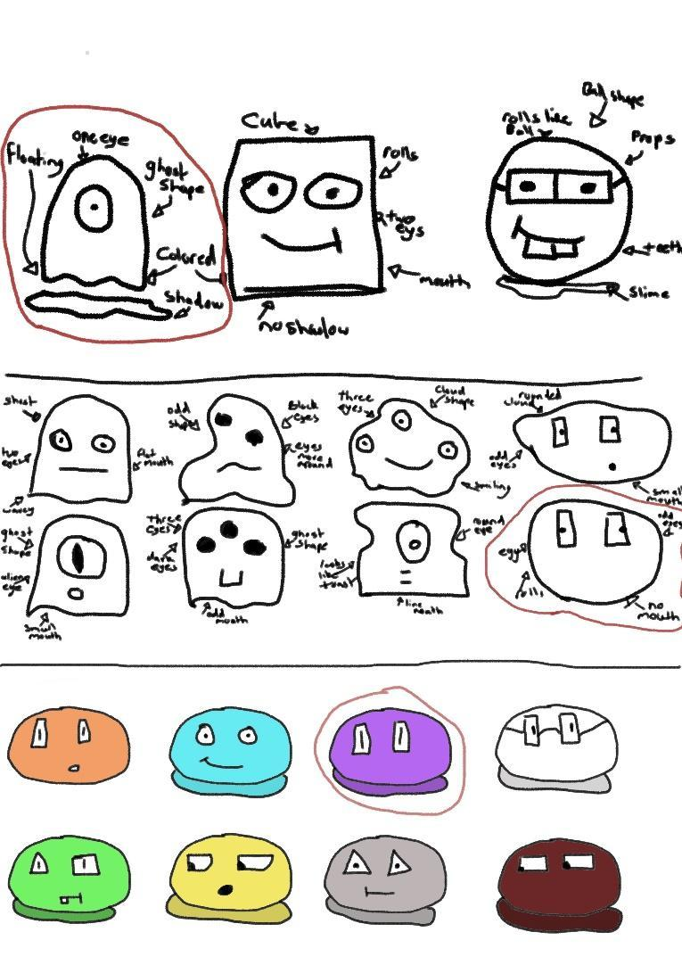

*Final Design:*

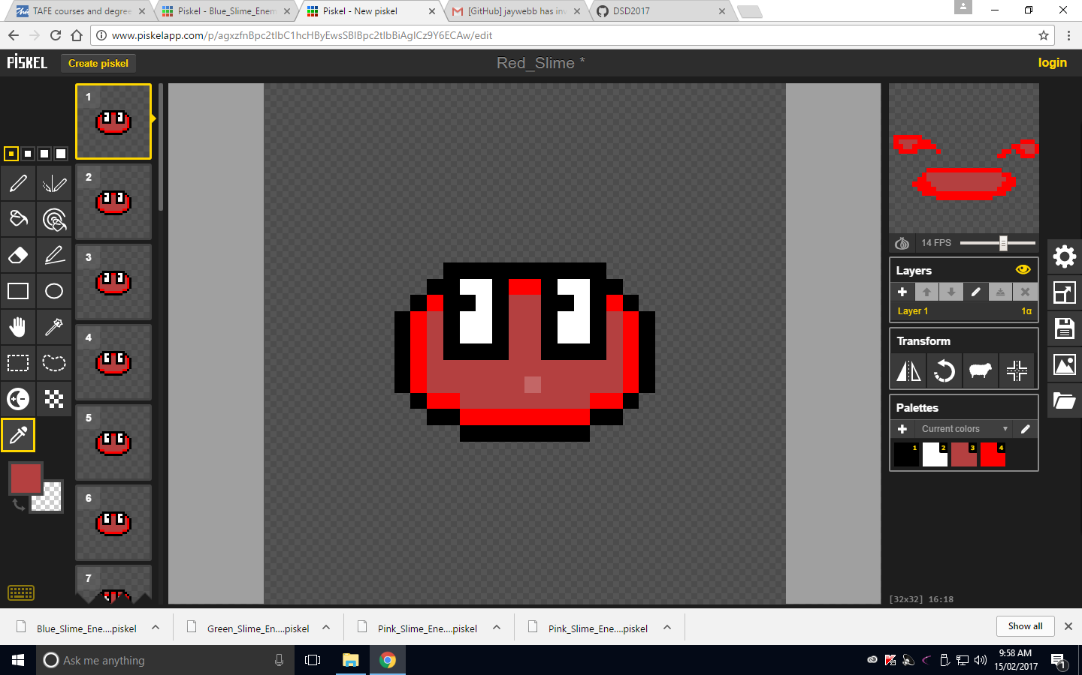

## *Enemy Character:*

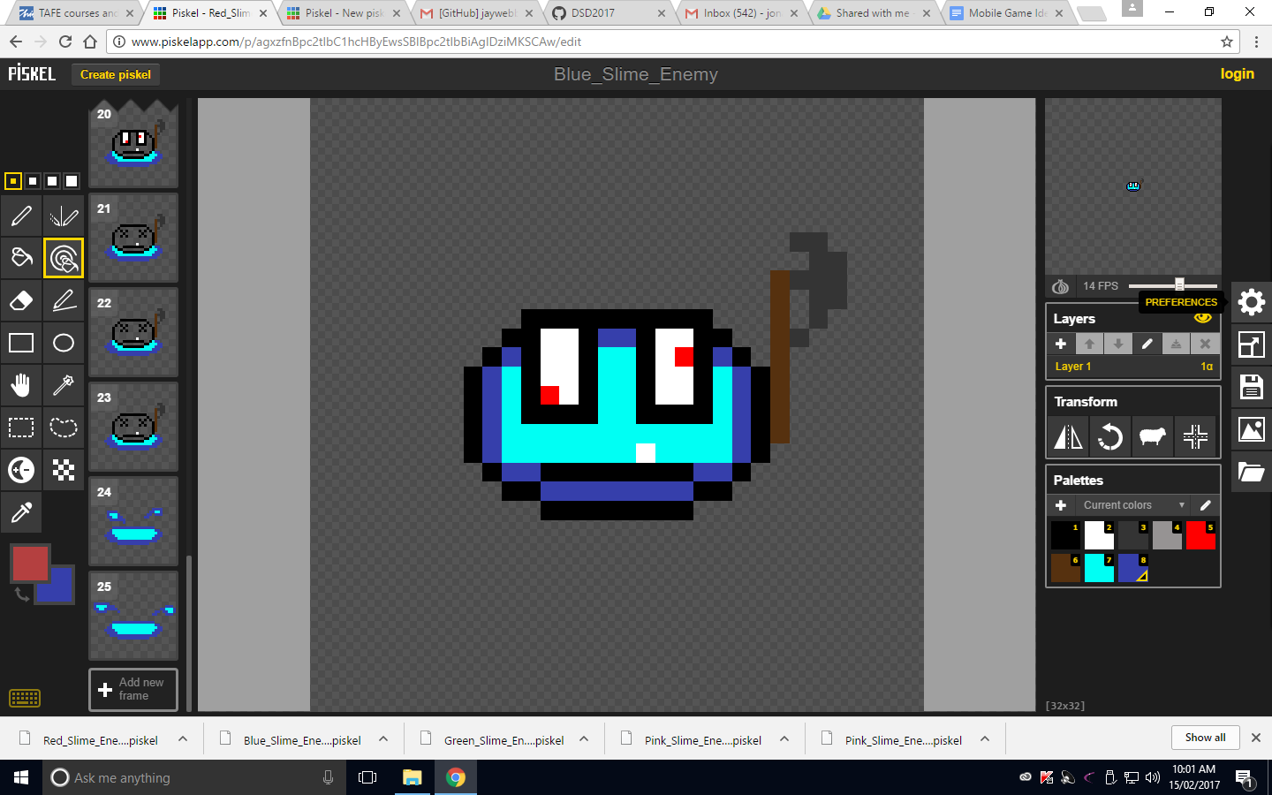

# Checklist:

*Design(artwork/assets):*

* *Concept Art*
* *Final design*
* *Level/Room design*
* *Menu layout*
* *Splash screen*
* *Game layout (font, colour)*
* *Audio/Sound design*

*Mechanics (Individual Blueprint):*

* *Health system*
* *Enemy Health*
* *Clone Health*
* *Enemy AI*
* *Patrol*
* *Attack clones*
* *Death*
* *Time Power system*

*character movement*

* *Record main*

*character actions*

* *Playback record*
* *Switch system*
* *Coloured switch system*
* *Door control system*
* *Object system*
* *Box/object Controller*
* *Spawn system*
* *Enemy Spawn*
* *Main character Spawn*

*Gameplay (Level Blueprint)-Trent:*

* *Difficulty score*
* *Increase room difficult*
* *Enemy Spawn Control*
* *Time system*
* *Track live time*
* *Add to next level*
* *Restart*
* *Menu system*
* *Pause*
* *Quit*
* *Control system*
* *Joystick control*
* *Attack control*
* *Use control*
* *Audio system*
* *Menu sounds*
* *Animation sound*
* *Background music*
* *Save/Load system*
* *Save Current room*
* *Load Current room*

*Optional:*

* *Auto Generate Level*
* *Get player difficulty*
* *High score*
* *Debug system*
* *God Character*
* *Level Skip*
* *Enemy rate*